**Information Visualization –Programming with D3.js**

**Car Data Insights: A Visual Dashboard**

**Live Dashboard Link:** [**https://gannavarapu-priya.github.io/IV_Project/**](https://gannavarapu-priya.github.io/IV_Project/)

**Git Hub Link:** [**https://github.com/gannavarapu-priya/IV_Project.git**](https://github.com/gannavarapu-priya/IV_Project.git)

**Individual Contribution Report: Sai Laxmi Priyanka Gannavarapu**

**Role:** Developed the time-series analysis and hosted the dashboard.

I led the creation of the **Line Chart** visualizing how fuel efficiency (MPG) evolved across different regions (USA, Europe, Japan). My key tasks included:

**Time-Series Visualization:** Coded a dynamic line chart in D3.js with color-coded regions for easy comparison.

**Enhanced Interactivity:** Added **zoom/pan** for detailed year-range inspection and **legend filters** to toggle regions.

**User-Friendly Features:** Implemented hover tooltips showing exact MPG values per year and origin.

**Deployment:** Set up the live dashboard on **GitHub Pages**, ensuring accessibility and responsiveness.

**Image Suggestion:**

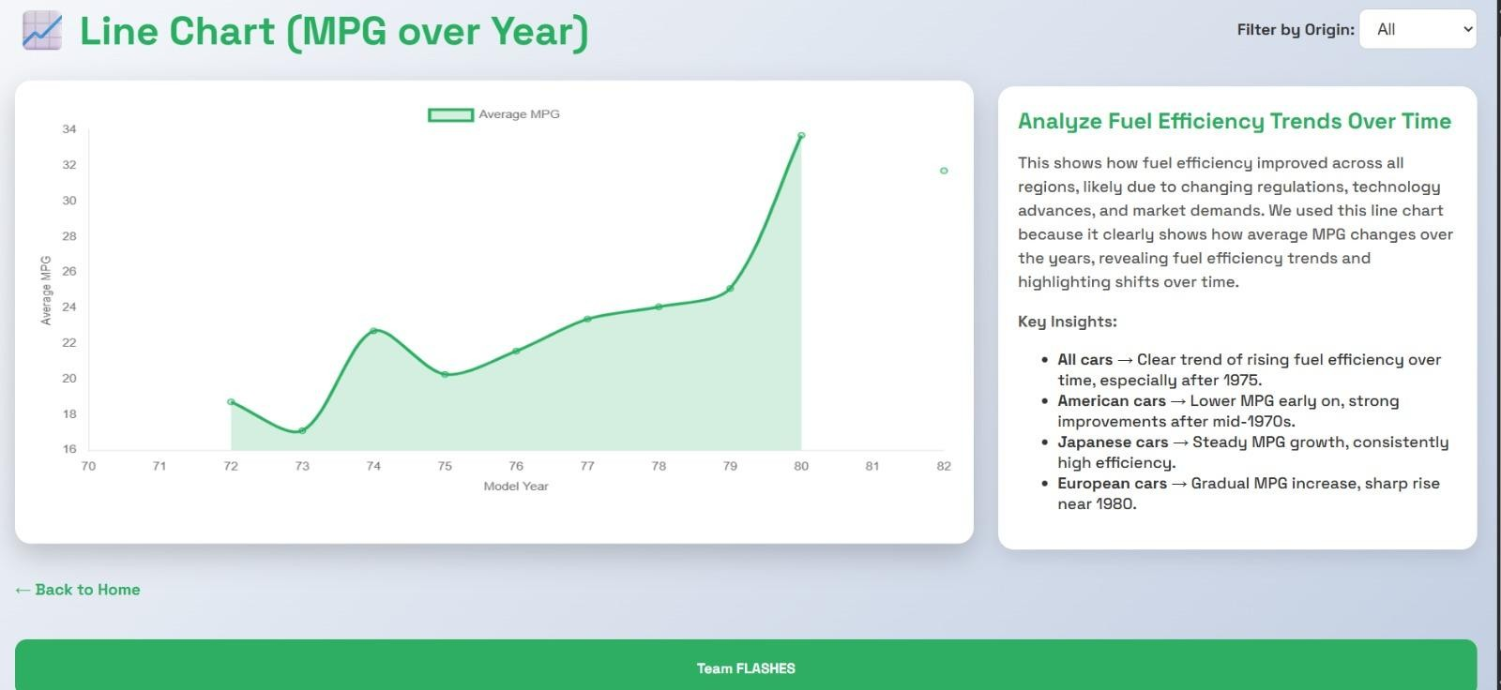

**Caption:** *"My line chart—tracking fuel efficiency trends over time."*